1. When you subscribe to **ActivatedRoute.params.subscribe**((params: Params)🡺{someCode}); and you move to some other component and in the component in which you subscribe, needs to unsubscribe. Angular takes care of it. But if you use your own observable then you need to explicitly unsubscribe.   
   When you leave this component, the component is destroyed and when you come back, the component is created.
2. Let’s see how to do that in the following example even though you don’t need to do so. Just for learning purpose.  
   You implement your own destroy life cycle hook by implanting **OnDestroy**
3. 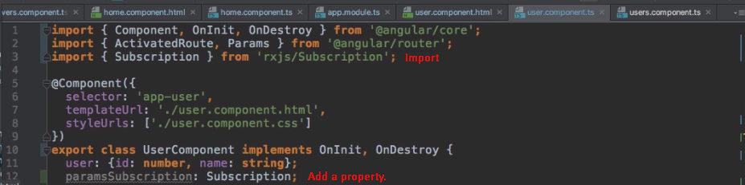**NOTE**: rxjs package is by 3rd party but Angular heavily uses it.   
   